**Computech**

**DEPT, OF COMPUTER SCIENCE & APPLICATION**

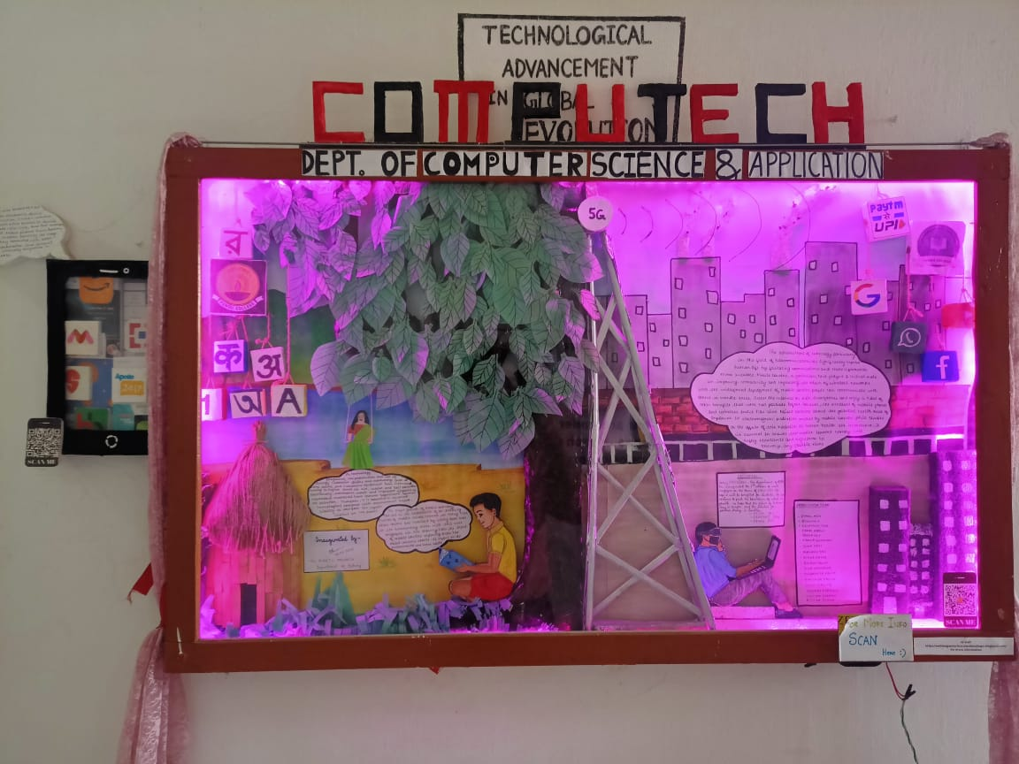

As technology progresses, the production and use of energy intensive devices and machinery, such as Cars, planes and industrial equipment have increased leading to higher levels of air, water, and soil pollution Additionally, electronic waste and improper disposal of hazardous materials have become significant sources of pollution. Therefore, it is essential to balance technological progress with environment Responsibility to mitigate the negative impact on the planet



The rapid growth of mobile technology has led to the installation of an increasing number of mobile towers. However, in many cases, these towers are installed by cutting down trees in the surrounding areas, with this wall magazine we are showing how the trend of mobile towers replacing trees has Raised concerns abouts its impact on the environmental and human health.

The advancement of technology, particularly in the field of telecommunications, has significantly impacted" human life by facilitating communications and make information more accessible. Mobile towers, in particular, have played a critical role in improving connectivity and expanding the reach of wireless networks. with the widespread deployment of mobile towers, people can communicate with Others in remote areas, access the internet on their smartphones and enjoy a host of other benefits that were not possible before. However, the increased of mobile phones and wireless device has also raised concerns about the potential health risk of Exposure to electromagnetic radiation emitted by mobile towers. while studies On the effects of this Radiation on human health are inconclusive, it is essential to ensure that mobile towers comply with safely standards and regulation to minimize any possible risks

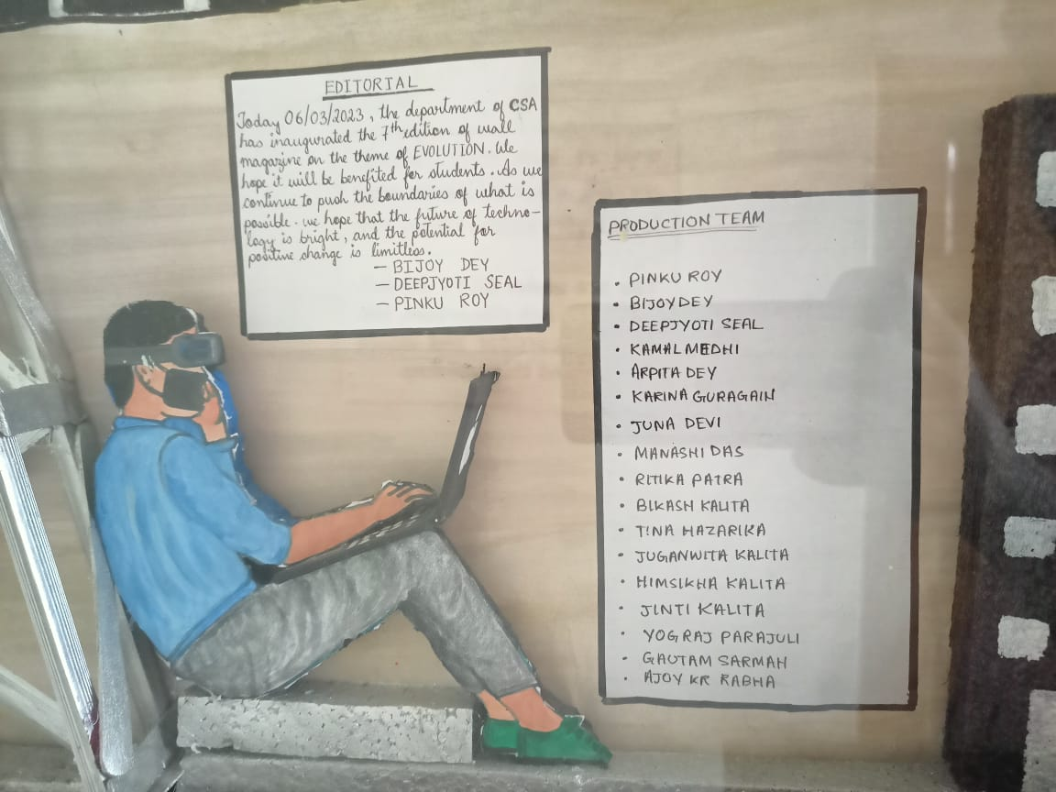

A mobile phone, also known as a cell phone, is a portable electronic device used for communication it uses a wireless network to connect with other phones or devices. enabling users to make voice calls, send text messages and access the internet. Mobile phones have become an integral part et modern society, as they allow people to say connected with each other, access information and conduct business from viretually anywhere in the world.

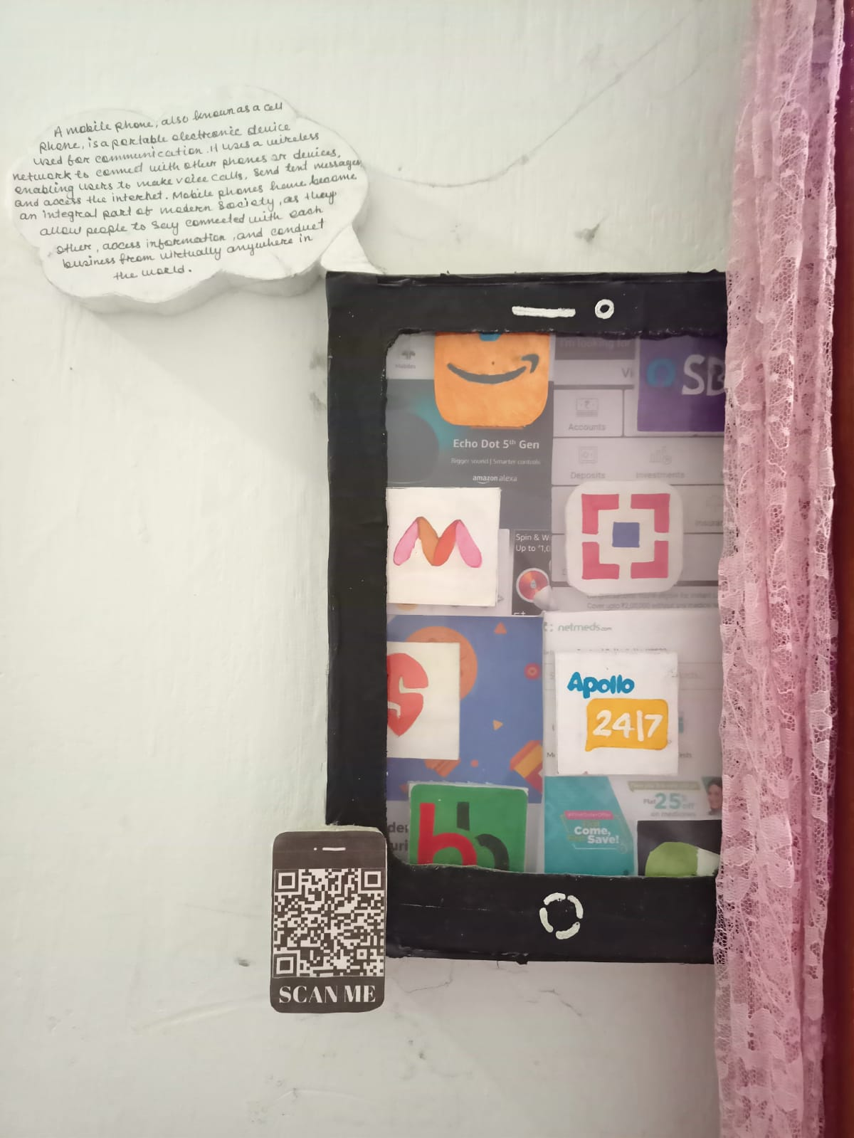****

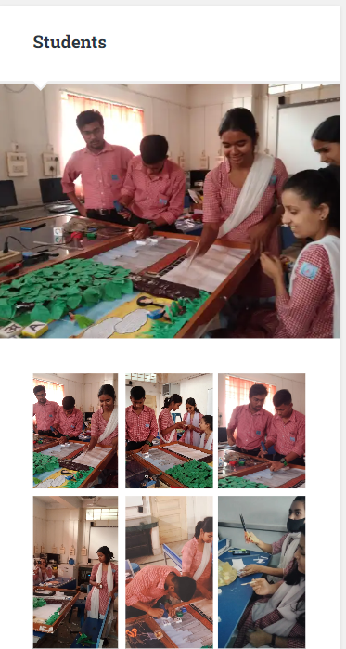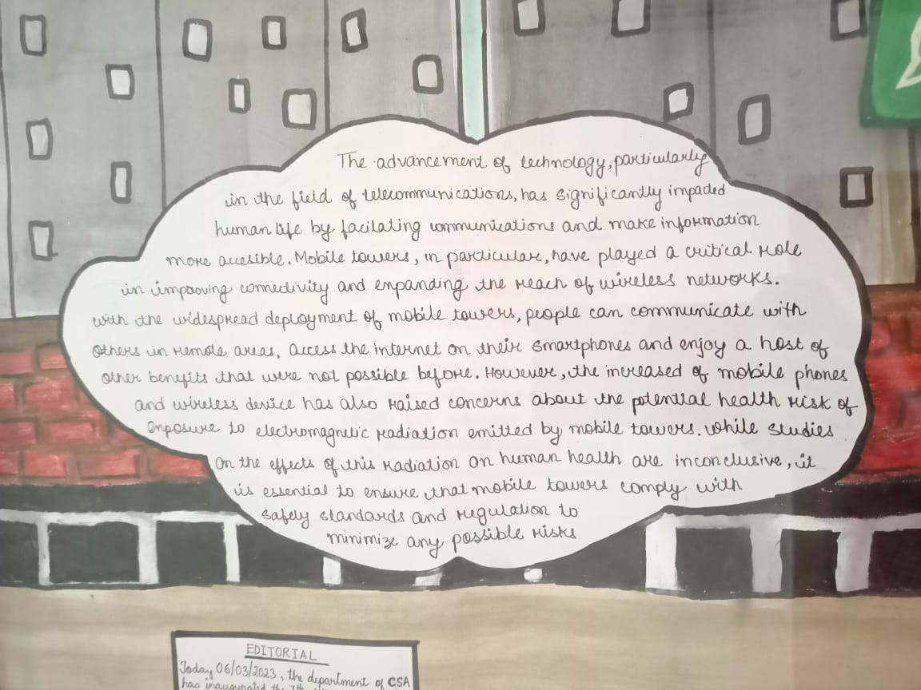

**EDITORIAL**

Today 06/03/2023, the department of CSA has inaugurated the 7th edition of wall magazine on the theme of EVOLUTION. We hope it will be benefited for students. As we continue to push the boundaries of what is possible, we hope that the future of technology is bright, and the potential for positive change is limitless.

- BIJOY DEY

- DEEPJYOTI SEAL

- PINKU ROY

- KAMAL MEDHI

**Production Team :**

* Bijoy Dey
* Deepjyoti Seal
* kamal Medhi
* Pinku Roy
* Arpita Dey
* Karina Guragain
* Juna Devi
* Ritika Patra
* Manashi Das
* Himsikha kalita
* Tina Hazarika
* Jinti Kalita
* Juganwita Kalita
* Bikash Kalita
* Ajoy Kumar Rabha
* Yograj Parajuli
* Gautam Sarmah